Examiners Benchmarking Research for Minnesota Banking Department

CSBS Analytics and Research

03 February, 2017

# Executive Summary

This study applies statistical models to benchmark the number of bank examiners employed by each state banking department vs. the number of banks and the total assets under supervision in each state. Benchmarking in this way provides a guideline as to where a particular state stands in terms of examiner resource when compared with other states. There is a statistically significant correlation between the number of examiners and both the total amount of assets under supervision as well as the number of state banks. The models uses 2015 data. The preliminary results show that the subject agency, the Minnesota Department of Commerce, is understaffed by 29 examiners when compared to other states across the US. These findings are in alignment with those of the Examiner Resource Model -- a simple comparison tool developed by CSBS. 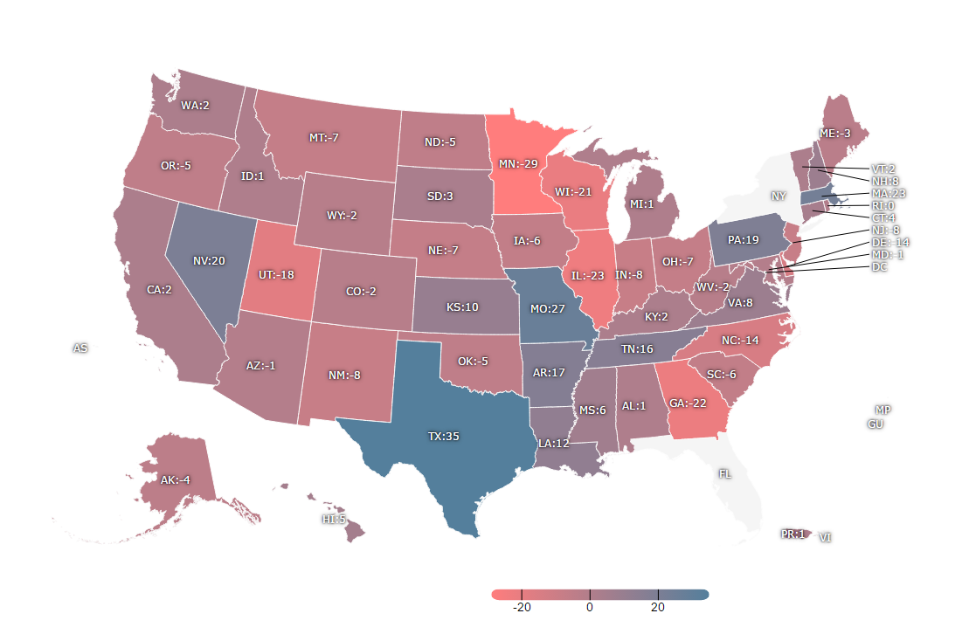

# Purpose

The purpose of this study is to determine whether there is a correlation between the number of examiners, number of bank charters, and total assets under supervision for a given state banking department. This will allow for a state by state comparison, allowing one to determine the staffing needs of the Minnesota Department of Commerce.

# Data Description

## Data Overview

The study uses consolidated 2015 Profile of State Chartered Banking data and Statistics on Depository Institutions (SDI), a publicly available bank data source, as of Q4 2015.

*Source:*

1. FDIC website. <https://www5.fdic.gov/sdi/main.asp?formname=customddownload>
2. Profile of State Chartered Banking Data.

## Relevant variables:

*Explanatory variable*:

* Number of Examiners by State (N_PF_EXAMINER)

*Independent variable*:

* Aggregate assets under supervision by the department (SDI_TOTAL_ASSET)
* Number of state chartered banks by state (N_SDI_BANK)

# Methodology

## Assumptions:

The following assumptions were made when constructing this model. Individual circumstances may vary from these assumptions and so should be kept in mind when interpreting the results.

1. There is a linear relationship between the independent variables and dependent variables.
2. The independent variables are not random. There is no exact linear relationship between any independent variables.
3. The locations of the banks will not have a significant impact on the time of examining work.
4. All the states follow similar examining process.
5. The CAMELS rating of previous year doesn't have a significant impact on the time of examination for the current year[1].
6. Bank examiners of all the states meet the similar productivity standards.
7. The diversity of the bank assets is already considered in bank size, thus will not have a significant impact on the time of examining work.

## Model: Multiple Linear Regression Model

A multiple linear regression model is defined as

$$y_{i}=α+β_{i}x_{i}+ϵ_{i}$$

in which $ϵ_{i}$ is the error or residual associated with observation *i*.

Profile of State Chartered Banking Data for District of Columbia and Iowa were not available for 2015. Data from 2014 were used for these two states.

The data distribution was drawn in R. After removing New York as the outlier, we observed a linear relationship between aggregated total asset chartered by state and number of state examiner.

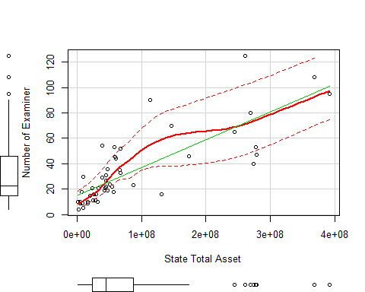

*Figure 1*

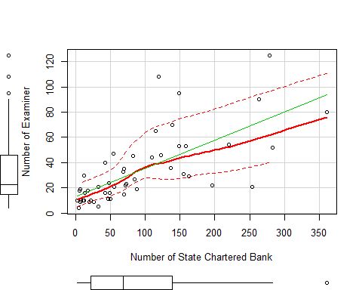

*Figure 2*

**Model Output from R**

Call:  
lm(formula = N_INT2_EXAMINER ~ SDI_TOTAL_ASSET + N_SDI_BANK,   
 data = rdb)  
  
Residuals:  
 Min 1Q Median 3Q Max   
-28.63 -6.62 -0.44 4.49 35.44   
  
Coefficients:  
 Estimate Std. Error t value Pr(>|t|)   
(Intercept) 6.52e+00 2.79e+00 2.34 0.024 *   
SDI_TOTAL_ASSET 1.68e-07 2.01e-08 8.33 8.3e-11 ***  
N_SDI_BANK 1.41e-01 2.35e-02 6.01 2.6e-07 ***  
---  
Signif. codes: 0 '***' 0.001 '**' 0.01 '*' 0.05 '.' 0.1 ' ' 1  
  
Residual standard error: 12.9 on 47 degrees of freedom  
Multiple R-squared: 0.793, Adjusted R-squared: 0.785   
F-statistic: 90.2 on 2 and 47 DF, p-value: <2e-16

The number of asterisks represents the degree of significance where *** indicates strong correlation and * indicates weak correlation. Both variables are significant in our model. *Aggregate assets under supervision by the department* (*SDI_TOTAL_ASSET*) is the most significant variable. The R-square indicates the percentage of data captured in the trend. According to the output shown above, 79% of the data are explained in this model. In other words, the dominant variable in determining the staffing size of a state banking agency is the total bank assets chartered by that agency. The number of banks chartered by a state banking agency is a secondary, but important, factor.

In consequence, the Number of Examiner for a State Department can be approximated with the following linear equation:

$$Number of Examiner=1.677×{10}^{−7}*Total Asset+0.141*Number of Bank+6.524$$

The equation shows that the coefficient for total assets is $1.677×{10}^{−7}$. It indicates that, other variables remaining the same, for each $10 billion assets increase, there should be about 1.7 more examiners. The coefficient for number of banks is 0.141. It indicates that, other variables remaining the same, for each increase of 10 banks, there should be 1.4 more examiners.

Minnesota chartered 254 banks, $ $4.341×{10}^{10}$ holding over $4 billion in total bank assets and employed 21 examiners as of Dec 31st, 2015.

# Conclusion

The model finds that in 2015, the estimated number of examiners needed in Minnesota, given its relatively high number of charters and its sizeable assert base, was approximately 50. Accordingly, Minnesota appeared to be understaffed by 29 examiners in 2015.

# Appendix

Figure 3 displays the number of examiners gap and the percentage of examiners gap for each reporting state banking department.

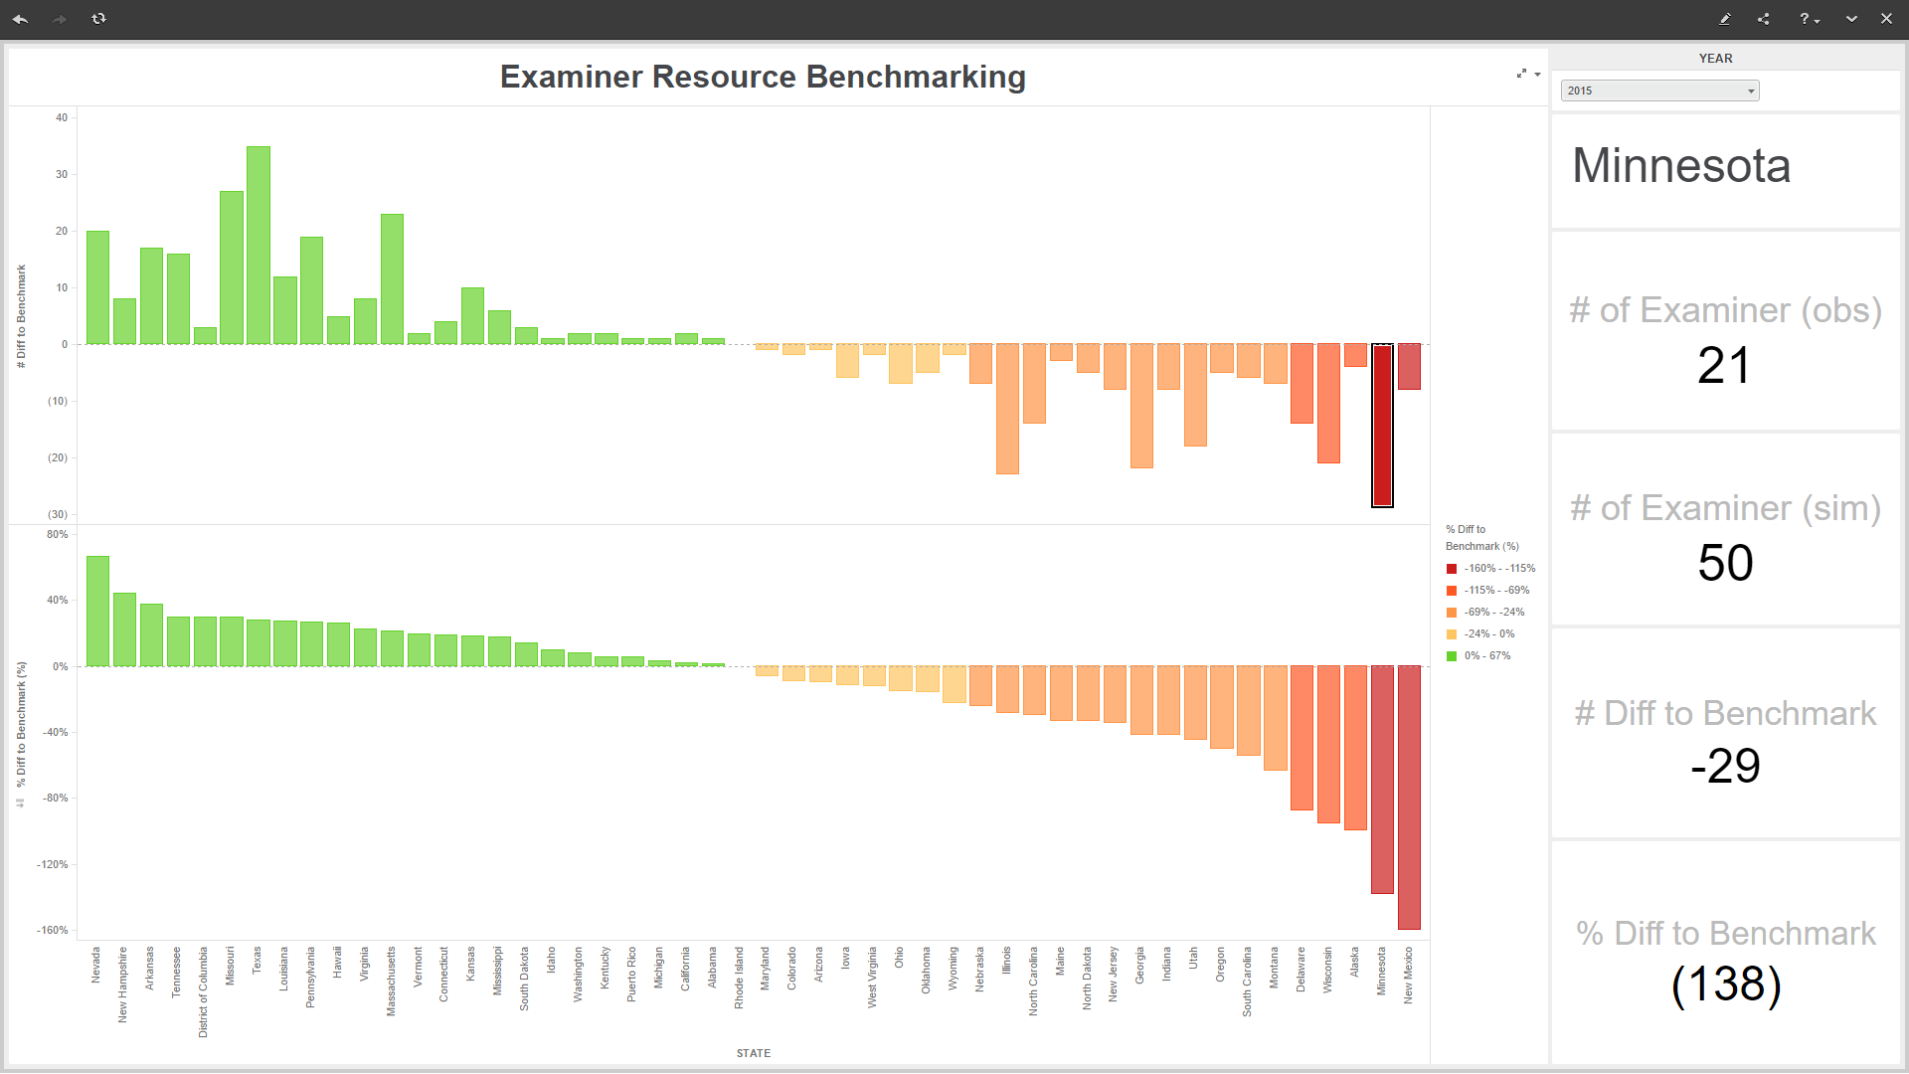 *Figure 3*

1. It is widely understood among bank regulators that the financial condition of the institution is a driving factor of examination resources. In times of economic stress, the demands on an agency's bank examination staff increase.